Report: Big Mountain Resort: Guided Capstone Step 6

Big Mountain Resort (BMR) is a ski resort in Montana serving 350,000 customers/year. BMR installed an additional chair lift that costs an extra $1.54M/year. The purpose of my analysis was to determine whether BMR can justify and implement a ~$5 ticket price increase to generate an additional $1.75M in revenue before the beginning of the next ski season by analyzing ticket prices from resorts with comparable amenities.

The dataset was originally a 330 row x 27 column csv with each entry corresponding to an American ski resort. Resorts from 35 states were included. I dropped all rows that lacked the features of interest (weekday and weekend ticket prices), yielding a revised dataset with 277 rows, and created state-level metrics from the revised dataset. See Fig 1 for a box-and-whisker plot describing summary statistics for ticket price by state.

Exploratory analysis (Fig 2) indicated that resort night skiing state ratio correlated with price: if a resort provides a greater share of the night skiing, they might be able to charge more for tickets. FastQuads and total chairs also correlated with price, indicating that people may be willing to pay more for good transportation to the runs. Finally, runs and snow making acreage correlated with price. Runs and snow making both increase the amount of skiing available to consumers.

To train my model, I created a 70/30 split of the dataset for training and testing, excluding the BMR entry. I imputed missing values using mean and median and found that median performed better. I created both linear regression and random forest regression models and found that the random forest model performed slightly better. I found that the most important features for price in this model were vertical drop, snow making_ac, total_chairs, fastQuads, and Runs (Fig 3).

My modeling predicted the price to be $96; even with an error of $10, this suggests BMR could charge $5 more per ticket than its current price of $81. If the average visitor purchases 5 tickets at the higher price, this will generate an additional $8.75M for BMR, covering the cost of the new chair lift.

I modeled several other potentially profitable situations for BMR and found that BMR could charge $2 more per ticket if they add a run, increase vertical drop by 150 feet, and install an additional chair lift. I also modeled run closures and found that BMR could close a few runs without impacting price. In the future, it would be helpful to obtain operating cost information for existing and proposed features as well as visitor traffic information for all resorts in the dataset.

Figure 1: box-and-whisker plot depicting ticket price summary statistics by state

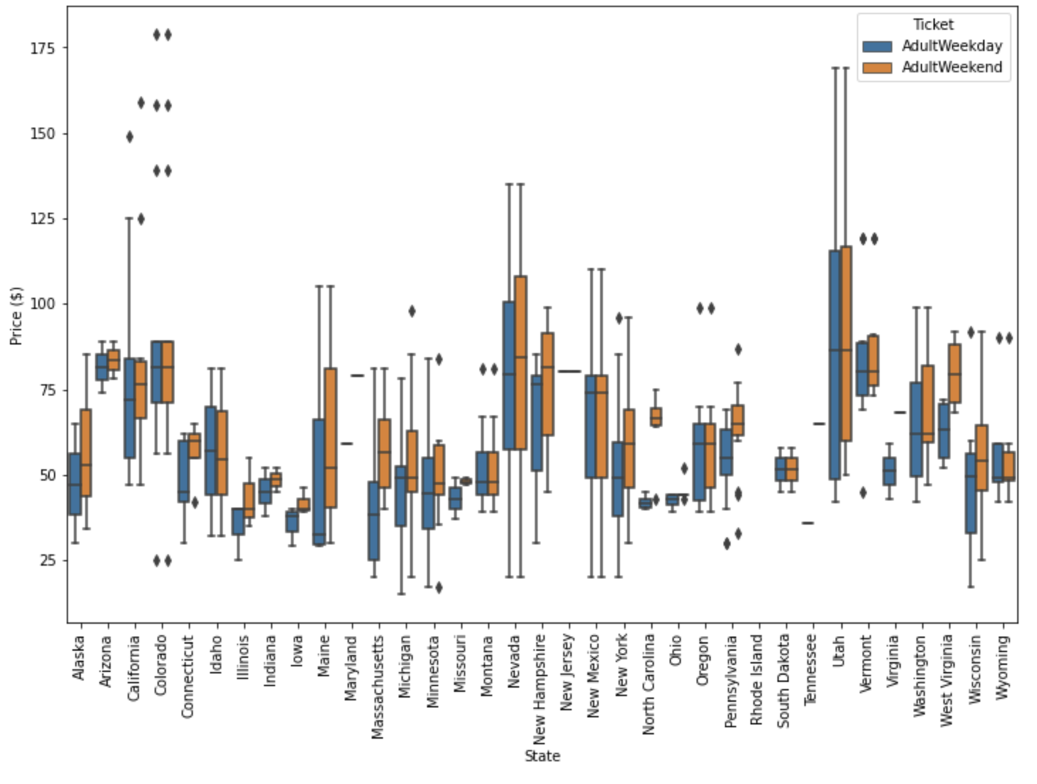

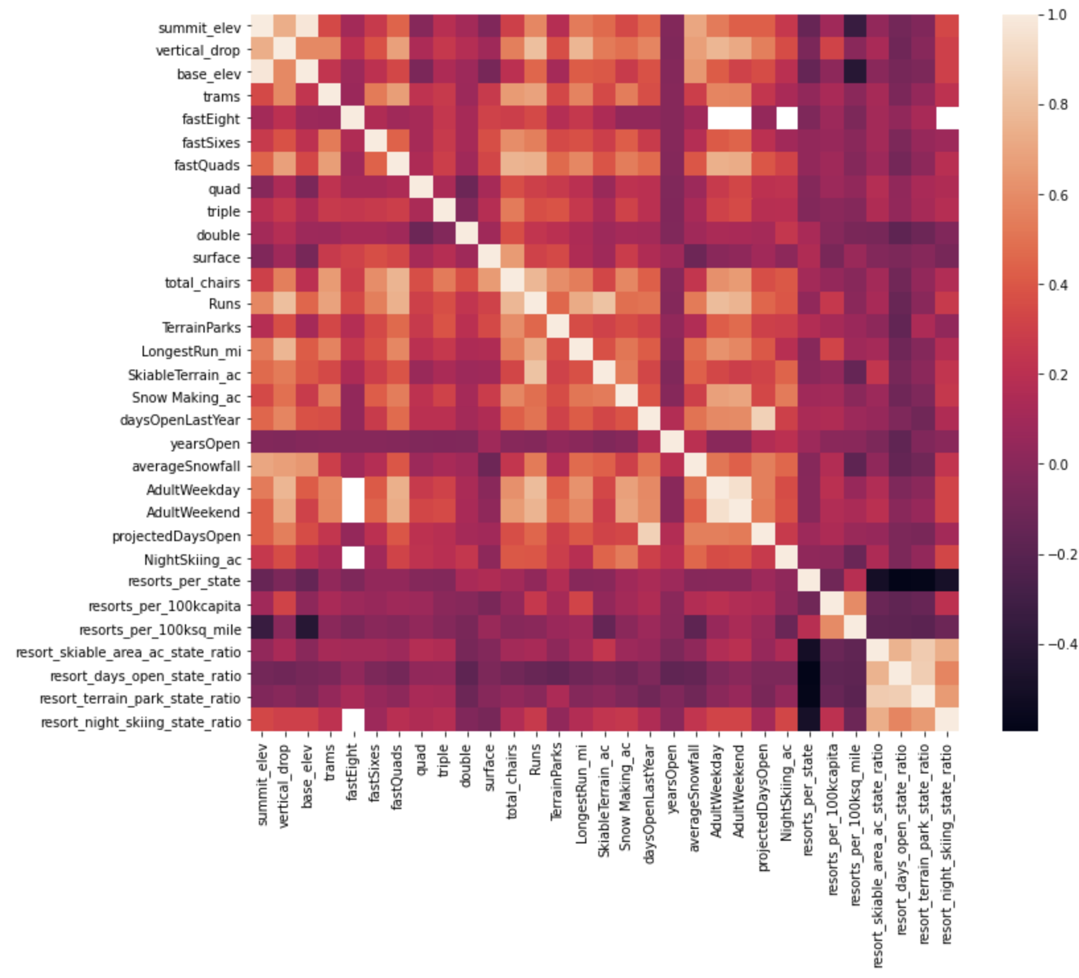Figure 2: heat map showing which features correlated with ticket price

Figure 3: bar chart that depicts which features were most important to the random forest model

